**Performance Assessment – Review – Help Sheet**

This help sheet is provided to help guide you thru the tasks in the Performance Assessment-Review. You **do not** need to submit this help sheet.

**Task 1 – Setting up the network**

Your instructor has assigned you a unique student number. This will be your number throughout the term and will not change. Write your student number on the line below and use it throughout the lab where indicated by an underscore.

Your network is:

**10._____.0.0/16**

In Packet Tracer, drag three 4321 routers onto the desktop

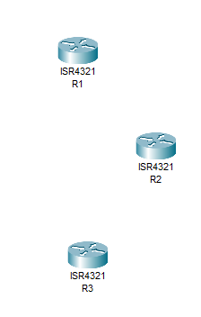

You will now need to add a serial module- NIM-2T and a SFP (small form-factor pluggable)- GLC-LH-SMD to each router.

Click on a router and go the Physical tab. 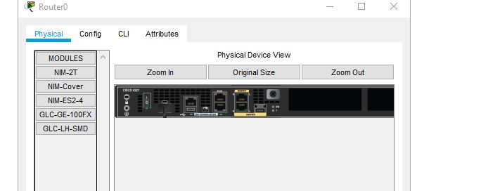



You will first need to turn the router off by clicking the power switch to off.

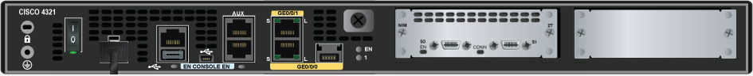

Drag a NIM-2T (serial port card) into the slot on the left and drop it in. In the next slot drag a NIM-Cover and drop it in.

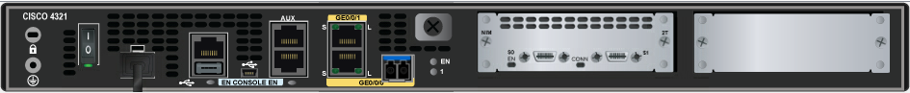

Add the GLC-LH-SMD module to the G0/0/0 port

Turn your router back on. Make sure follow these steps for all three routers.

Change the name of each router to R1, R2, and R3. You can do this by clicking on the text Router1 and then updating the name to R1.

Now connect the routers together using a serial DCE connection (the one with the clock).

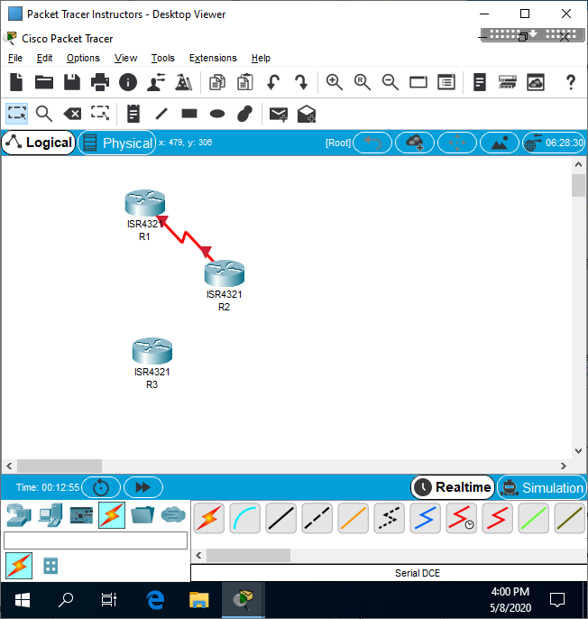

Click and drag from the R1 router S0/1/0 to the R2 router and connect to S0/1/1.

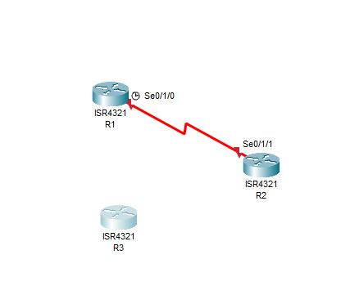

Click and drag from the R2 router (connect to S0/1/0) to the R3 router and connect on S0/1/1.

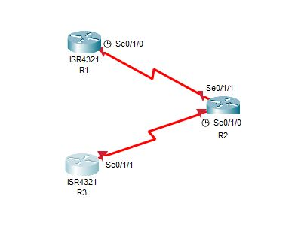

Finally connect from the R3 router, S0/1/0, to the R1 router on S0/1/1.

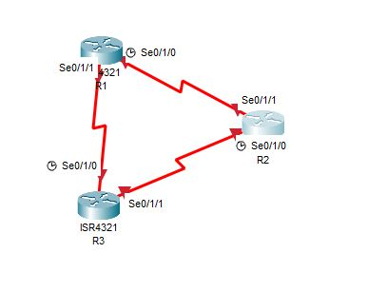

You will notice that everything shows up with red lights and that is okay. Nothing will turn green until you have programmed the routers.

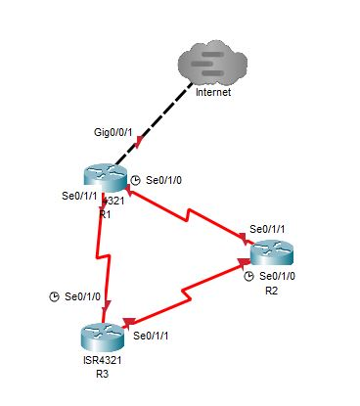

You will connect R1 to a Multiuser Cloud using Gig0/0/1 on R1 and connect to the cloud using a cross-over cable. Rename the cloud to Internet.

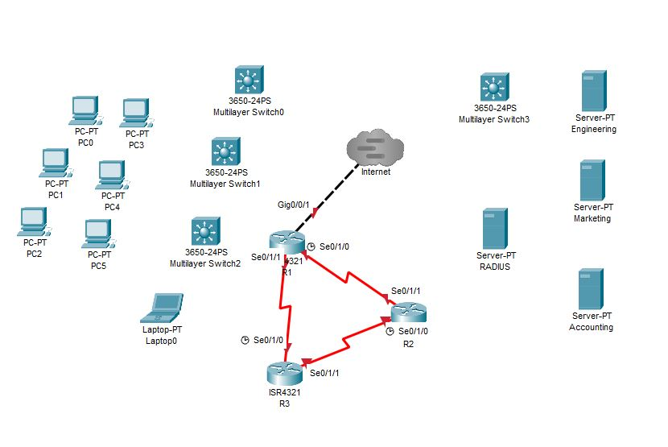

Drag and drop the rest of the equipment for the network onto the desktop. This will be four 3560 switches, six PCs, and four servers. Make sure you rename the servers (RADIUS, Engineering, Marketing and Accounting). You will be adding more PCs and Laptops in a later step.

Setting up the 3650 switch

Initially your switch will appear as it does below.

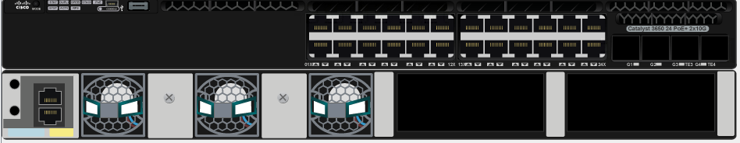

The first thing you must move into the switch are the power supplies, AC-POWER-SUPPLY, that are at the bottom of the screen

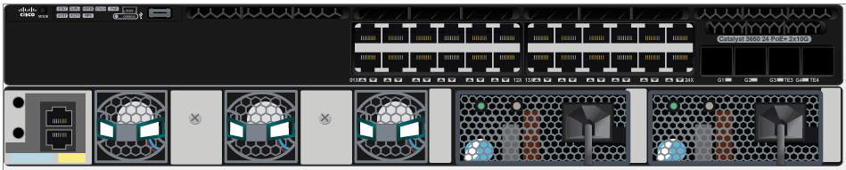

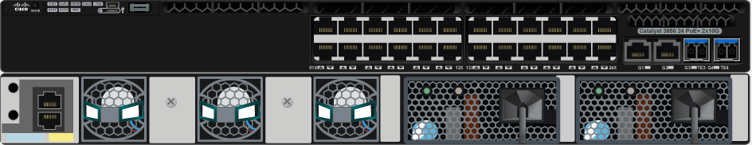

Next you will place two of the GLC-T SFPs and two GLC-LH-SMD SFPs into the right side of the switch

Connect from the G0/0/0 port on R2 to the G1/1/1 port on Sw0 using a copper straight-through cable

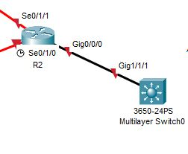

Configure Sw0. Make sure you change the hostname to Sw0.

Would you like to enter the initial configuration dialog? [yes/no]:

no

Switch>enable

Switch#configure terminal

Switch(config)#hostname Sw0

Sw0(config)#interface range g1/0/1-5

Sw0(config-if-range)#switchport mode access

Sw0(config-if-range)#switchport access vlan 10

Sw0(config)#interface range g1/0/6-10

Sw0(config-if-range)#switchport mode access

Sw0(config-if-range)#switchport access vlan 20

Sw0(config)#interface range g1/0/11-15

Sw0(config-if-range)#switchport mode access

Sw0(config-if-range)#switchport access vlan 30

Sw0(config)#interface range g1/0/16-20

Sw0(config-if-range)#switchport mode access

Sw0(config-if-range)#switchport access vlan 40

Sw0(config-if-range)# interface range g1/1/1-4

Sw0(config-if-range)#switchport trunk encapsulation dot1q

Sw0(config-if-range)# switchport mode trunk

Now setup and program Sw1-3 exactly the same way you did Sw0. Don’t forget to add the power supplies and the SFPs.

Connect your four servers to GE1/0/1 (Engineering), GE1/0/6 (Marketing), GE1/0/11 (Accounting), and GE1/0/16 (RADIUS) of Sw0.

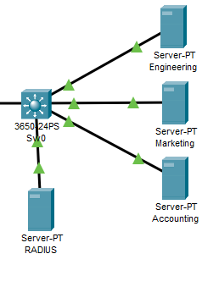

Connect the G0/0/0 port on R3 to G1/1/1 port on Sw1.

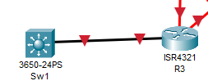

Connect the switches together from G1/1/1 to G1/1/1 and G1/1/2 to G1/1/2 using straight through cables

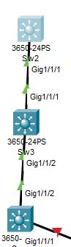

Finally connect your PCs to each switch- For Sw1 use G1/0/1, G1/0/6, G1/0/11, and G1/0/16. Each PC/laptop will be on its own VLAN. PC1 will be in VLAN 10, PC2 in VLAN 20, PC3 in VLAN 30 and Laptop1 in VLAN 40. Follow these steps for Sw2 and Sw3 as well. The end result will have four devices off of each switch, and each being in its own VLAN. Add enough PCs and Laptops to make the connections below.

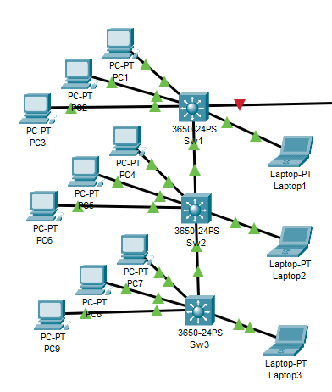

You will notice that the switches, PCs, and server all turned green meaning they are ready. This is because no programming is required for these systems to work on the network.

Now you will need to go in and program each of the routers.

Click on the R1 router and go to the CLI tab. This is the command line interface which you will be using to program your routers.

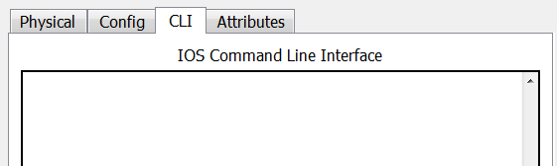

You may need to type the enter key a couple of time to wake the system up.

You will now see the router prompt for the system

--- System Configuration Dialog ---

Would you like to enter the initial configuration dialog? [yes/no]: no

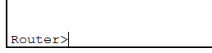

Type the command **enable** in order to enter privileged mode. You can tell you are in privileged mode because the prompt turned to a # symbol.



Type the command **configure terminal** and then **hostname** with the name of the router (R1)

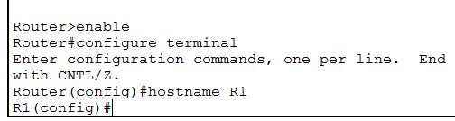

You will notice the prompt will change to the name you have given your system. This is important so you can keep your systems straight as you are programming them.

Now you will go through each of your routers and program the information for each interface.

|  |  |  |  |  |  |
| --- | --- | --- | --- | --- | --- |
| **System** | **Port** | **Connect To** | **IP address** | **Subnet Mask** | **Clock Rate** |
| R1 | G0/0/1 | Internet | 11.0.0.___ | 255.255.255.0 |  |
|  | Se0/1/0 | R2 | 10.___.5.1 | 255.255.255.252 | 500000 |
|  | SE0/1/1 | R3 | 10.___.5.10 | 255.255.255.252 |  |

R1(config)# **interface g0/0/1**

R1(config-if)# **ip address 11.0.0.___ 255.255.255.0**

R1(config-if)# **no shutdown**

R1(config)# **interface s0/1/0**

R1(config-if)# **ip add 10.___.5.1 255.255.255.252**

R1(config-if)# **clock rate 500000**

R1(config-if)# **no shutdown**

R1(config-if)# **interface s0/1/1**

R1(config-if)#**ip add 10.___.5.10 255.255.255.252**

R1(config-if)#**no shutdown**

|  |  |  |  |  |  |
| --- | --- | --- | --- | --- | --- |
| **System** | **Port** | **Connect To** | **IP address** | **Subnet Mask** | **Clock Rate** |
| R2 | G0/0/0.10 | Sw0 | 10.___.2.1 | 255.255.255.192 | Engineering Server |
|  | G0/0/0.20 | Sw0 | 10.___.2.65 | 255.255.255.192 | Marketing Server |
|  | G0/0/0.30 | Sw0 | 10.___.2.129 | 255.255.255.192 | Accounting Server |
|  | G0/0/0.40 | Sw0 | 10.___.2.193 | 255.255.255.192 | RADIUS Server |
|  | Se0/1/0 | R3 | 10.___.5.5 | 255.255.255.252 | 500000 |
|  | SE0/1/1 | R1 | 10.___.5.2 | 255.255.255.252 |  |

Use the table above to configure R2. You will need to get into global configuration mode first like you did already for R1.

R2(config)# **int g0/0/0**

R2(config-if)# **no shutdown**

R2(config-if)# **int g0/0/0.10**

R2(config-subif)# **enc dot1q 10**

R2(config-subif)# **ip add 10.___.2.1 255.255.255.192**

R2(config-subif)# **int g0/0/0.20**

R2(config-subif)# **enc dot1q 20**

R2(config-subif)# **ip add 10.___.2.65 255.255.255.192**

R2(config-subif)# **int g0/0/0.30**

R2(config-subif)# **enc dot1q 30**

R2(config-subif)# **ip add 10.___.2.129 255.255.255.192**

R2(config-subif)# **int g0/0/0.40**

R2(config-subif)# **enc dot1q 40**

R2(config-subif)# **ip add 10.___.2.193 255.255.255.192**

R2(config-subif)# **int s0/1/0**

R2(config-if)# **ip add 10.___.5.5 255.255.255.252**

R2(config-if)# **clock rate 500000**

R2(config-if)# **no shutdown**

R2(config-subif)# **int s0/1/1**

R2(config-if)# **ip add 10.___.5.2 255.255.255.252**

R2(config-if)# **no shutdown**

Your network number plus one. For example, if your number is 50, it would be 51 here.

|  |  |  |  |  |  |
| --- | --- | --- | --- | --- | --- |
| **System** | **Port** | **Connect To** | **IP address** | **Subnet Mask** | **Clock Rate** |
| R3 | G0/0/1 | Internet2 | 11.0.0._(+1)_ | 255.255.255.0 |  |
|  | G0/0/0.10 | Sw1 | 10.___.3.1 | 255.255.255.224 | Engineering- 28 Users |
|  | G0/0/0.20 | Sw1 | 10.___.3.33 | 255.255.255.240 | Marketing- 12 Users |
|  | G0/0/0.30 | Sw1 | 10.___.3.49 | 255.255.255.240 | Accounting-10 Users |
|  | G0/0/0.40 | Sw1 | 10.___.3.65 | 255.255.255.248 | 5 Users |
|  | Se0/0/0 | R1 | 10.___.5.9 | 255.255.255.252 | 500000 |
|  | SE0/0/1 | R2 | 10.___.5.6 | 255.255.255.252 |  |

R3(config)# **int g0/0/0**

R3(config-if)# **no shutdown**

R3(config-if)# **int g0/0/0.10**

R3(config-subif)# **enc dot1q 10**

R3(config-subif)# **ip add 10.___.3.1 255.255.255.224**

R3(config-subif)# **int g0/0/0.20**

R3(config-subif)# **enc dot1q 20**

R3(config-subif)# **ip add 10.___.3.33 255.255.255.240**

R3(config-subif)# **int g0/0/0.30**

R3(config-subif)# **enc dot1q 30**

R3(config-subif)# **ip add 10.___.3.49 255.255.255.240**

R3(config-subif)# **int g0/0/0.40**

R3(config-subif)# **enc dot1q 40**

R3(config-subif)# **ip add 10.___.3.65 255.255.255.248**

R3(config-subif)# **int s0/1/0**

R3(config-if)# **ip add 10.___.5.9 255.255.255.252**

R3(config-if)# **clock rate 500000**

R3(config-if)# **no shutdown**

R3(config-subif)# **int s0/1/1**

R3(config-if)# **ip add 10.___.5.6 255.255.255.252**

R3(config-if)# **no shutdown**

Now set up your OSPF routing protocol on each router.

R1(config)# **router OSPF 1**

R1(config-router)# **network 10.___.5.0 0.0.0.3 area 0**

R1(config-router)# **network 10.___.5.8 0.0.0.3 area 0**

R1(config-router)# **network 11.0.0.0 0.0.0.255 area 0**

For R2 and R3

R2(config)# **router OSPF 1**

R2(config-router)# **network 10.___.5.0 0.0.0.3 area 0**

R2(config-router)# **network 10.___.5.4 0.0.0.3 area 0**

R2(config-router)# **network 10.___.2.0 0.0.0.63 area 1**

R2(config-router)# **network 10.___.2.64 0.0.0.63 area 1**

R2(config-router)# **network 10.___.2.128 0.0.0.63 area 1**

R2(config-router)# **network 10.___.2.192 0.0.0.63 area 1**

R3(config)# **router OSPF 1**

R3(config-router)# **network 10.___.5.4 0.0.0.3 area 0**

R3(config-router)# **network 10.___.5.8 0.0.0.3 area 0**

R3(config-router)# **network 10.___.3.0 0.0.0.31 area 1**

R3(config-router)# **network 10.___.3.32 0.0.0.15 area 1**

R3(config-router)# **network 10.___.3.48 0.0.0.15 area 1**

R3(config-router)# **network 10.___.3.64 0.0.0.7 area 1**

Verify that your network is set up correctly by typing.

R1# **show ip route**

Verify that you can ping from one router to another by typing the following on R1

R1# **ping 10.___.5.5**

Type escape sequence to abort.

Sending 5, 100-byte ICMP Echos to 10.___.5.5, timeout is 2 seconds:

!!!!!

Success rate is 100 percent (5/5), round-trip min/avg/max = 1/5/21 ms

**Setting up DHCP on your server**

There are two methods assign IP addresses on a network- assigning static IP addresses and DHCP addresses. In this task you will be programming a server to assign IP addresses using DCHP.

First we need to configure our servers with static addresses.

Open your servers and go to the Desktop tab and click on the IP configuration square.

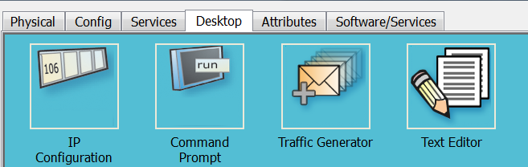

Type in the following IP address information.

**Engineering Server-**

IP Address- 10.__2.2

Subnet Mask- 255.255.255.192

Default Gateway- 10.__2.1

**Marketing Server-**

IP Address- 10.__2.66

Subnet Mask- 255.255.255.192

Default Gateway- 10.__2.65

**Accounting Server-**

IP Address- 10.__2.130

Subnet Mask- 255.255.255.192

Default Gateway- 10.__2.129

**RADIUS Server-**

IP Address- 10.__2.194

Subnet Mask- 255.255.255.192

Default Gateway- 10.__2.193

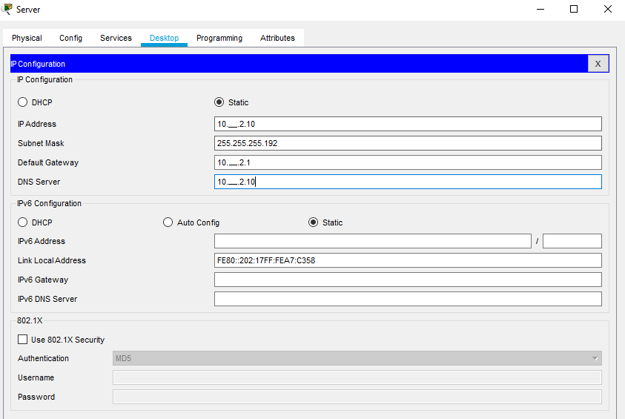

The reason you give a static IP address to your servers is so other systems can refer to them using this address and it will never change.

Now you will setup the DCHP pools for your PCs and laptops. In your RADIUS Server select the Services tab and select the DHCP service.

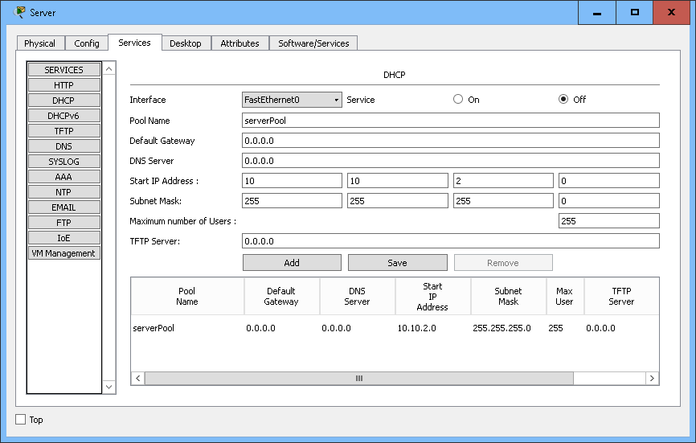

Turn the service on

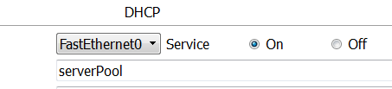

You will see that you already have one address pool assigned that will be for your server network. Change the serverPool information to the following:

Default Gateway: 10.___.2.1

DNS server: 10.___.2.10

Start IP address 10.___.2.11

Subnet Mask: 255.255.255.192

TFTP server: 10.___.2.10

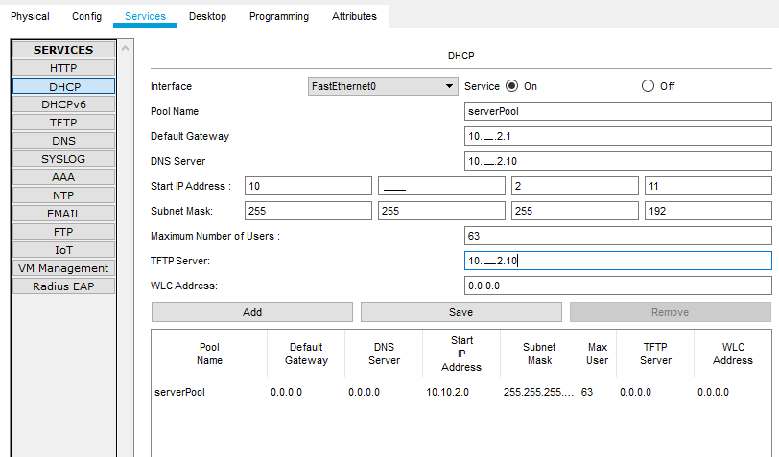

Press the save button to update the DHCP pool. You will see the serverPool parameters change to the new information.

Go back to the information at the top and change it to

Pool Name: 10

Default Gateway: 10.___.3.1

DNS server: 10.___.2.10

Start IP address 10.___.3.2

Subnet Mask: 255.255.255.224

TFTP server: 10.___.2.10

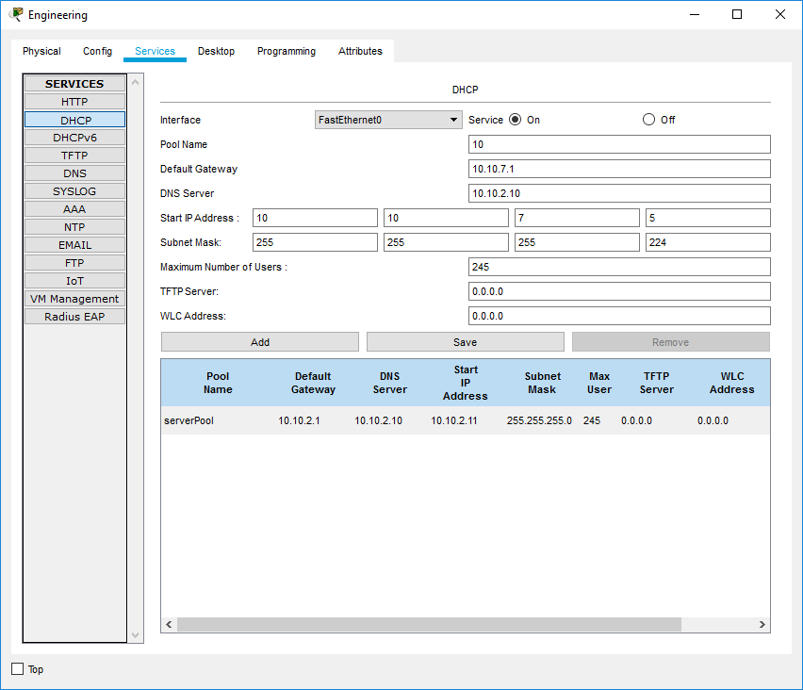

Press the Add button to create the new DHCP pool. You should now see the new pool on top of the DHCP pools on your server.

Go in and add the 20, 30, and 40 pools below.

Pool Name: 20

Default Gateway: 10.___.3.33

DNS server: 10.___.2.10

Start IP address 10.___.3.34

Subnet Mask: 255.255.255.240

TFTP server: 10.___.2.10

Pool Name: 30

Default Gateway: 10.___.3.49

DNS server: 10.___.2.10

Start IP address 10.___.3.50

Subnet Mask: 255.255.255.240

TFTP server: 10.___.2.10

Pool Name: 40

Default Gateway: 10.___.3.65

DNS server: 10.___.2.10

Start IP address 10.___.3.66

Subnet Mask: 255.255.255.248

TFTP server: 10.___.2.10

Only one other thing to do is to add a helper addresses into the R3 router.

R3(config)# **interface G0/0/0.10**

R3(config-int)# **ip helper-address 10.___.2.194**

R3(config)# **interface G0/0/0.20**

R3(config-int)# **ip helper-address 10.___.2.194**

R3(config)# **interface G0/0/0.30**

R3(config-int)# **ip helper-address 10.___.2.194**

R3(config)# **interface G0/0/0.40**

R3(config-int)# **ip helper-address 10.___.2.194**

You should now be able to go into your PCs, desktop tab and select IP configuration.

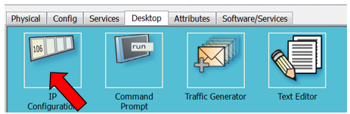

Change your IP configuration to DHCP. Your PCs should now be able to pull a DHCP address from your server.

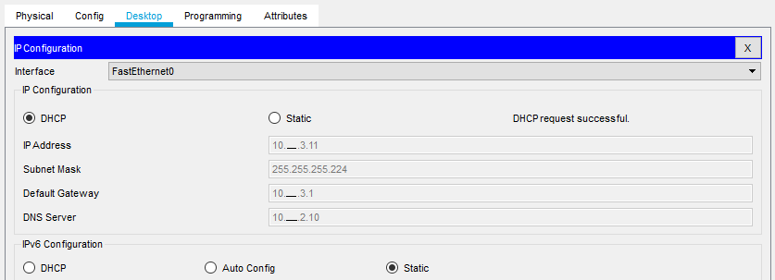

If it doesn’t work check to make sure you can ping the server for your R2 router. If you can there is another problem you will need to troubleshoot.

Troubleshooting your DHCP problems can be difficult. So, you need to sectionalize the problem.

* First check to make sure your pools on your server is correct. If any of your addresses are incorrect it will not work.
* Next check to make sure your helper-address on your router is correct. You can do this by typing **show run** on your router and checking your G0/0 interface. It should show the IP address of your server.
* Lastly, check to see if your DHCP service is turned on. By default, the service is off and you must turn the service on for it to work.

Check your system by pinging from PC2 to your server.

**Task 2 – Connecting to the Tier1 Network**

You will be using the Multiuser link to connect your corporate office through the Internet. First, make sure you have the multiuser connection on your packet tracer network. This icon looks like a cloud with three lines in it (not the cloud without them).

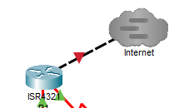

Go to Extensions at the drop-down menu and select multiuser and Listen.

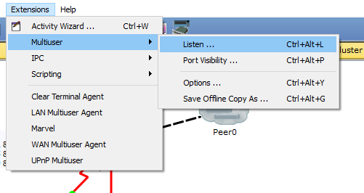

Remove the password (if any) and select always accept to both existing and remote networks.

Now click through Extensions and Port visibility

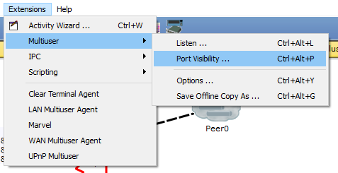

Select your ports of G0/0/0 and G0/0/1 on the R1 router and the G0/0/1 on the R3 router. These are the ports that will be available for connection to external users.

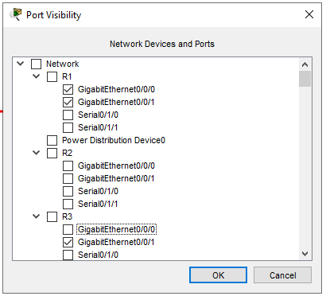

Open you Tier1Network and verify that you have the following network

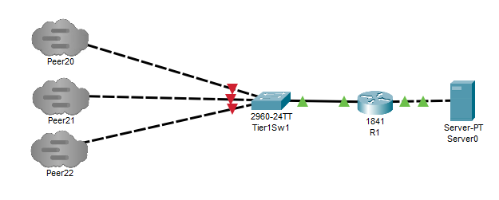

You should now have two networks open on your screen at the same time

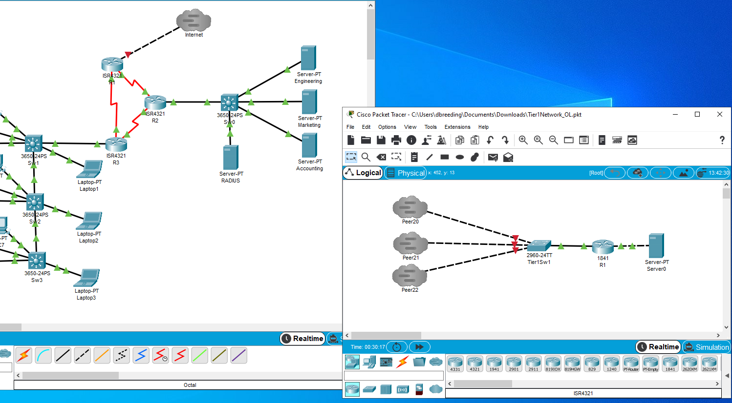

Verify the port number of your Tier1 Network by looking at the listen page of the multiuser dropdown menu. Write your port number below.

Port number ______________________________________________________

Click on the Multiuser cloud and type localhost and Peer port number for your tier1 network. You should use the Peer name of Peer20 on your connection.

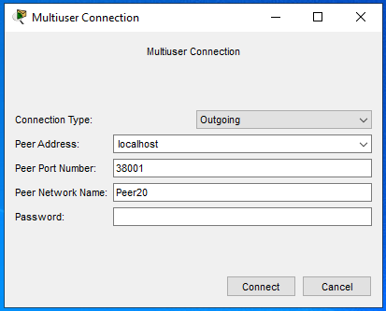

Click the connect button. You should now see the Peer connection cloud appear on the packet tracer screen as green or blue.

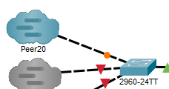

Wait for the connection to turn green on both sides. If the connect stays red you may need to disconnect and reconnect the cable going to the cloud. Select the link at the top of the cloud, not create a new link so you can connect to the system on the other side of the link.

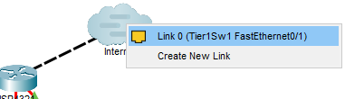

Now you are going to connect from your network into the Internet network using the multiuser cloud.

Click on your multiuser cloud and select outgoing connection. Add the Peer address of localhost, the peer port number of 38001 (it may be 38000) and the peer network name of Peer20.

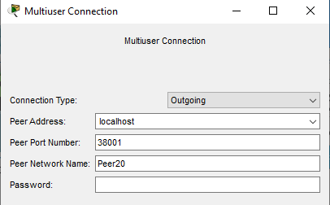

Click the connect button

A connection should now appear between your two packet tracer desktops. The cloud may initially turn green to indicate a new connection but will soon turn to blue.

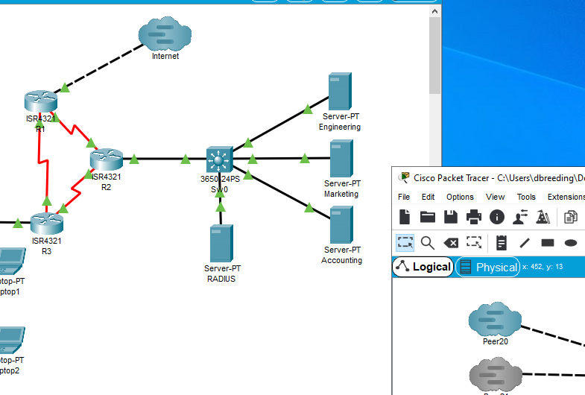

You may also need to disconnect and reconnect the cable going to your cloud if it doesn’t turn green reconnect with the link at the top (Link 0) not with create new link



The connection should now turn green to your router.

Check your connection to the Tier1 Network by going to R1 and pulling **show ip route**.

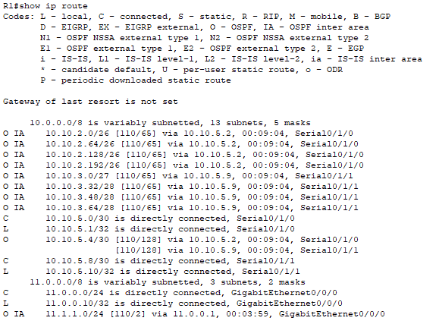

Ping the Tier1 Network server with one of your PCs. It is okay if you get a timeout (or even two) to start the process.

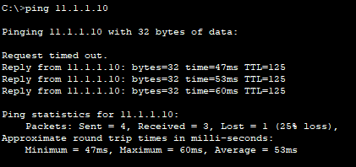

Now place a second Multiuser cloud from the R3 router as shown below.

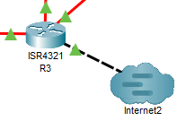

Connect the second Multiuser cloud to the Tier1 Network.

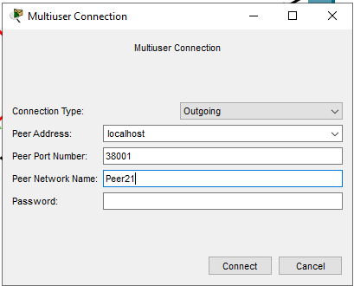

Configure the R3 router with the IP address **(add one to your student number for the second Tier1 address.)**

R3(config)# interface g0/0/1

R3(config-if)# ip address 11.0.0.___ (+1) 255.255.255.0

R3(config-if)# no shutdown

R3(config-if)#exit

R3(config)# router ospf 1

R3(config-router)# network 11.0.0.0 0.0.0.255 area 0

Pull a show ip route from the R2 router.

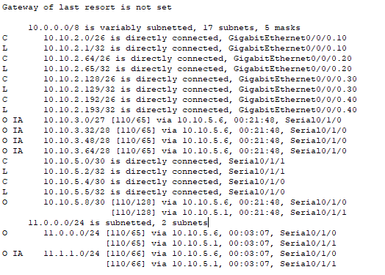

What is the difference with the show ip route on R2 router when the second cloud is connected? You may need to connect and disconnect the cloud several times for the differences to become obvious.

__________________________________________________________________________